**DATA CLEANING USING SQL**

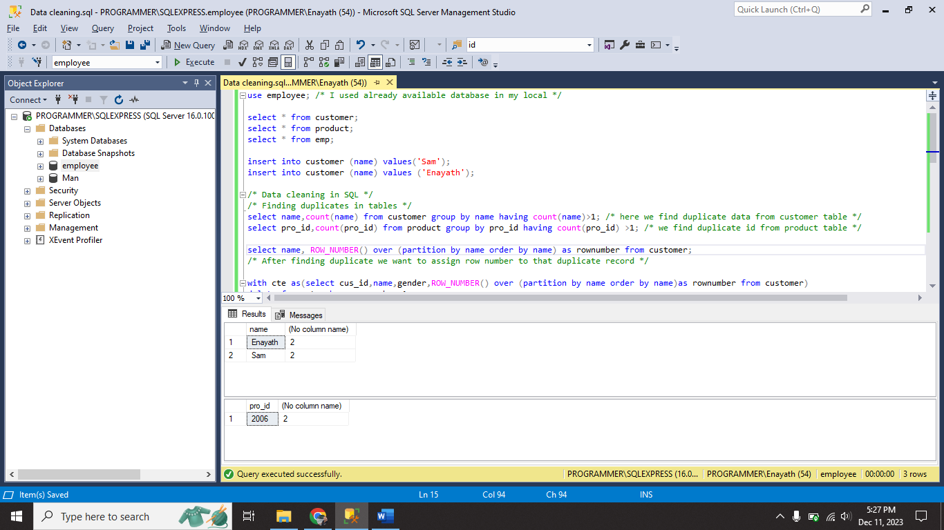

1. I finding duplicates in table.
2. After finding duplicates I assigned row number for that record.

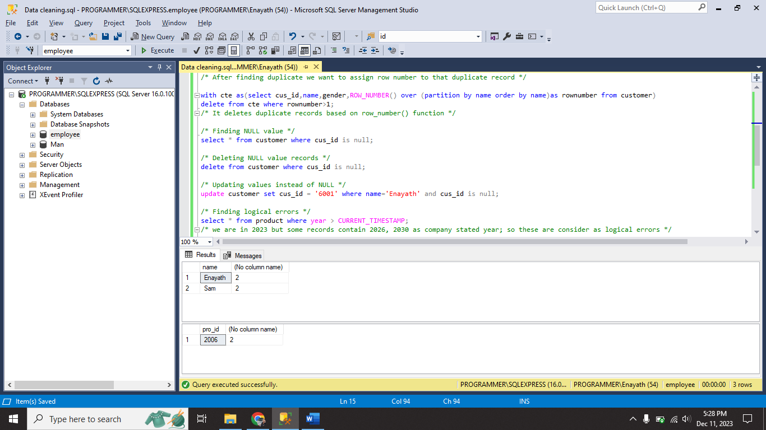

1. I deleted duplicate records using **ROW_NUMBER()** function with the help of temporary table.
2. I found NULL values in the table.
3. I deleted NULL value records using ‘**is**’ operator.
4. I updated some values instead of NULL value.

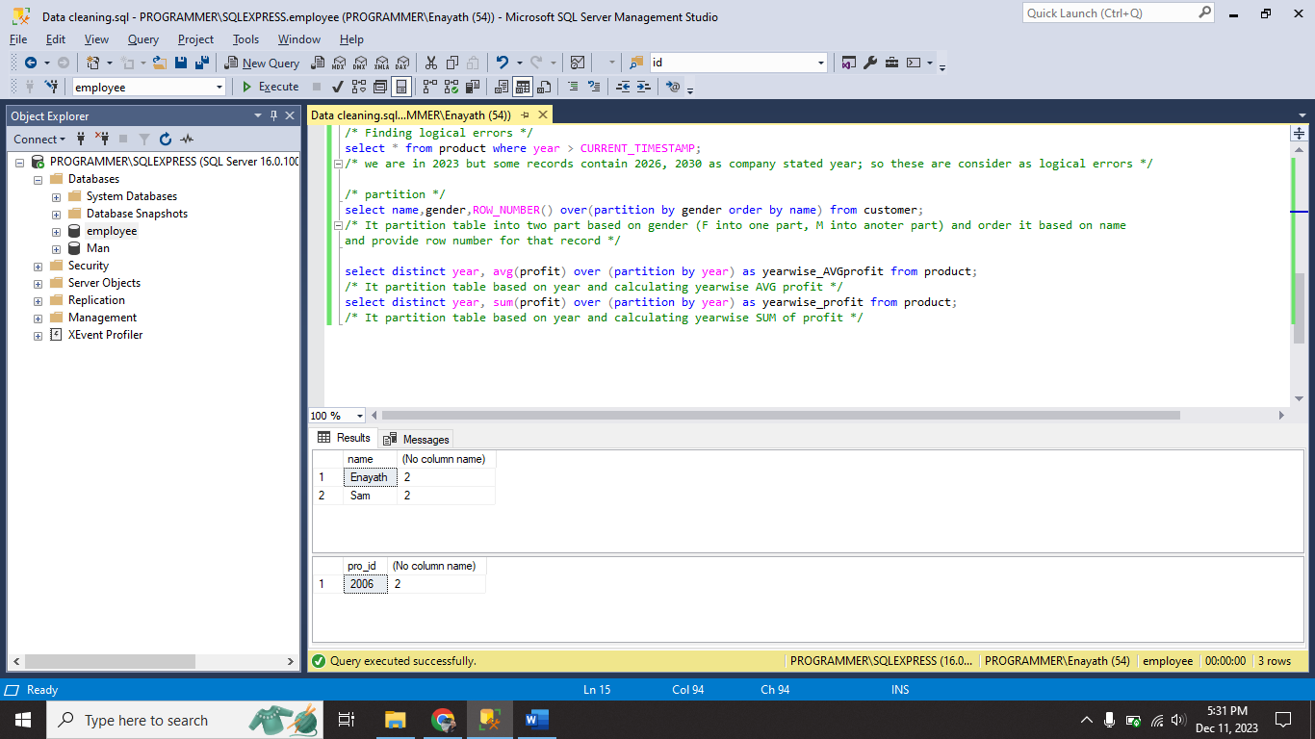

1. I found logically error records.
2. I used **PARTITION BY** for various performance on product table.